Water Monitoring ‘Survey 123’

When taking a water quality reading you will need to record this via the survey available via the ‘Survey 123’ app. You can download this to your phone from your preferred App store
Google Store - ESRI ArcGIS Survey 123
Apple Store - ESRI ArcGIS Survey 123 app
Once you have loaded the app using the QR code below you can access the relevant survey
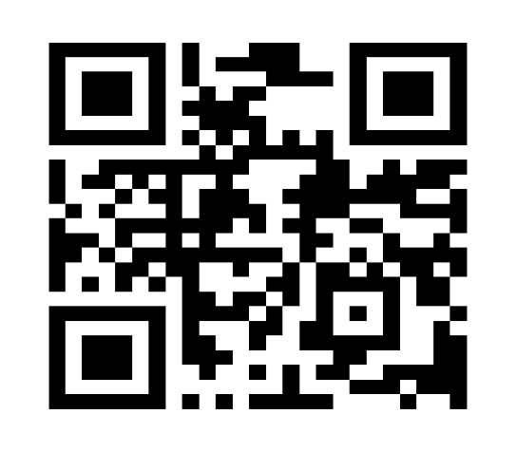
Or use the link
https://arcg.is/0aP0851
Either click the ‘Survey 123’ icon or search using the QR code icon shown on the right hand side of the search bar within the app.
This should take you to a signing in screen. The screen is titled ‘ArcGIS Survey 123’. The screen shows 3 options.
Click on ‘Continue without signing in’, it usually appears as the bottom option and does not have a box around it.
The ‘Water Monitoring’ survey should be available as an icon in the top left of the screen. Click on ‘Water Monitoring’.
A ‘Collect’ button should appear at the bottom of the screen. Click this button to add your data.

Taking and submitting a reading

- It is always advisable, where possible, to work in pairs. This provided additional safety but also an alternative perspective if you have any queries or concerns about your answers.

- Unwind the cable and ensure it is tangle free.

- Remove the opaque, blue coloured shroud from the monitoring probe. To do so, unscrew the upper black ring, this will allow you to slide the shroud off the probe unit. Take a little care as the shroud should contain a small amount of water when the probe is being stored and not in use.

- The probe can then be placed, dopped, lowered or thrown into the water at your selected site. The probe is reasonably robust but please take care to avoid throwing it into particularly shallow or rocky pools.

- Where possible try to sample as close to the centre of the water course as possible but please consider your own safety and do not take undue risks or enter the water when taking samples.

- Switch the handheld monitoring terminal. Press . The screen will initially display the YSI logo but after a couple of minutes should change to show the required results fields.

- Allow the results to settle. The numbers may initially alter and may take several (4/5) minutes to settle to a steady reading.

- Once you are ready to record your readings, open the Survey 123 App, (see previous notes) go to the water monitor survey and ‘collect’ the data requested.

Survey 123 Notes
Site Name
Select the site name by pressing the arrow on the righthand side of the answer box. This should display a dropdown list for you to select an existing site.
Alternatively, you can add a new site by selecting ‘other’. This provides an additional box which allows you to free- type your answer.

Water Quality/Habitat (Optional)
If possible, it would be helpful to complete this section. If you are unsure about what is meant, below is a little guidance for each classification.
Livestock Poaching: Damage caused to land and soil when livestock (cattle, sheep, etc.) tread on it causing the loss of soils or grass, leading to soil erosion, compaction, and potential water pollution
Litter: Unnatural waste e.g., cans, bottles, tyres ect in the watercourse or on the banks.
Aggravated erosion: Excessive or unnaturally rapid loss of soil and land due to human or livestock activities
Reinforcement (bank and bed): Artificial strengthening of riverbeds and/or banks using materials such as boulders or bricks.
- Should the screen go black/blank press the brightness button  to view the screen again.

- Once you have finished recording your data, and you are happy that you have recorded the data in Survey 123, switch off the handheld monitor. Hold the power button down for a few seconds, until ‘power off’ briefly appears.

- Remove the probe from the water and replace the blue shroud. The shroud should contain some water when the probe is being stored. This helps to protect the sensors. Please remember to remove any gravel, mud, silt or debris that may be on the probe before storing it away.

Submitting a survey

It is usually better to save the data into your outbox when in the field. This allows you an opportunity to edit the survey prior to it being submitted.
Once you are connected to a reliable internet connection don’t forget to check your survey and submit it.

